**About My Self:**

With over 13 years of experience, I am providing both quality assurance and third-party validation through a combination of consulting, and specialist services. I can manage complex work flow of web and mobile project. My automation experience can useful for longer run. Have good communicating & liasoning skills to work with Dev team at local as well as remote location. My passionate to find quality bugs every phase of SDLC at early stage to prevent later finding bugs and project cost. In short my profile can say given 100% ROI to organization.

Service offerings include every type of software testing including functional testing, mobile testing, test automation with DevOps and Agile team culture.

**QA SERVICES**

I have good experienced to performed varies Type of Testing in web based   
applications, including web service oriented architecture, mobile and desktop applications & deliver higher quality systems in lesser time to my client. Over a time my studies show that finding and fixing defects during test execution can cost 50 times more than during the early requirements phase so, I believe to find early stage defect which surly cut overall cost of project by a third.

Proudly said that I and my Team is expertise in manual as well as in automation testing. We are providing dedicated Testing Services unit focuses on Verification and Validation of products and applications. Our robust processes give assurance that our Verification and Validation services are consistent and industry standards quality.

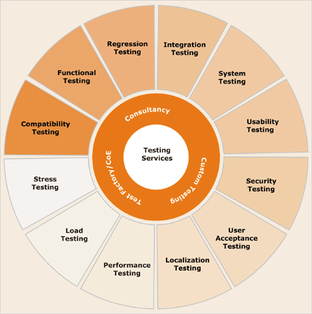

Offers following Testing Services:

* [Manual Testing](http://vnvtestlab.com/wordpress/testing-services/manual-testing/)
* [Automation Testing](http://vnvtestlab.com/wordpress/testing-services/automation-testing/)
* Functional, Usability, Multi-Platform Testing
* Integrated System Testing
* User Acceptance Testing(UAT)
* Mobile Testing
* System Testing

**Software Testing Life Cycle**

[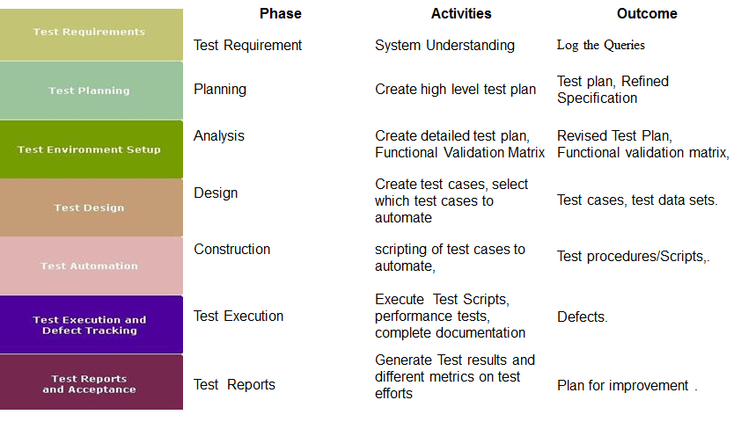](http://vnvtestlab.com/wordpress/wp-content/uploads/2011/12/SoftwareTestingLifeCycle2.png)

**Manual Testing:**

Manual testing plays an important role in Business critical applications and in applications where functionalities change quite often. Manual testing is essential, as 100 percent automation is not possible in real-time environment. In an agile methodology, manual testing holds upper hand over the automation. My expertise in delivering manual functional testing service on software applications across BFSI, Healthcare, Telecom, Retail and Logistics, Energy, and E-Learning domains and expert services in SOA, Security, Mobility, and Datacenter.

**Expertise in:**

* Client Server Application Testing
* Web application Testing
* Desktop Application Testing
* Test Cases Preparation using testing techniques such as Equivalence Partition, Boundary value analysis, Cause effect graphing, and Error guessing
* Test Strategy and Test Plan Preparation
* Manual Functional Test Execution
* Defect Tracking
* Regression Testing

# Automation Testing:

Automation Testing is the process of automating the steps of manual test cases and process them using an automation tool or utility. It helps in increasing test coverage and to shorten testing life cycle.

I have experienced in open source test automation tools.

* selenium webdriver with well managed automation framework to test web projects.
* Appium used for Mobile automation
* XCUITest used for iOS Mobile App automation

# User Acceptance Testing Services:

My User Acceptance Testing Services validate end-to-end business process, system transactions and user access, confirms the system or application is functionally fit for use and behaves as expected. Also, identifies areas where user needs are not included in the system or the needs are incorrectly specified or interpreted in the system.

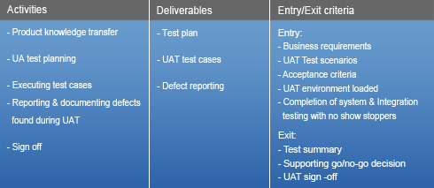

The Key Deliverables of User Acceptance Testing:

* The Test Plan- Outlining the testing strategy
* The User Acceptance Test cases – Helping the team to effectively test the application
* The Test Log – A log of all the test cases executed and the actual results
* User Sign Off – Customer buy-in, indicating customer finds the product delivered to their satisfaction

# Compatibility Testing Services:

My extensive experience in developing test suites and executing application level Compatibility tests across different software applications ensures harmony in business processes, information, technology, and solutions.

Compatibility testing verifies that the product functions as expected on a wide variety of hardware, software, and network configurations which are planned on an identified set of compatibility combinations. Compatibility testing is conducted on the application to evaluate its compatibility with the underlying environment. This environment may contain some or all of the below mentioned elements:

* Operating Systems (UNIX, Windows, etc.)
* Databases (Oracle, Sybase, DB2, etc.)
* Networking hardware and Hardware Platform (Firewalls, Proxies, etc)
* Compatibility of peripheral devices like Printer, DVD drive, etc.
* Other System Software (Web server, Application Server, etc.)
* Browser compatibility (Firefox, Internet Explorer, Safari, etc.)
* Any other hardware / software as required

# System Integration Testing:

System Integration Testing (SIT) ensures that the system meets the requirements of the formal specification document and also any implied, or ‘common sense’ requirements.

As a result, the application is tested in order to verify that it meets the standards set by the client as a part of the System Integration Testing.

I follow a Black Box approach to System Integration Testing. The focus is on testing the functional requirements for the applications.

SIT Test Design Techniques for developing Test Cases:

* **Equivalence partitioning**:The functionality of the component is divided into multiple equivalent portions.
* **Boundary value analysis:**Minimum and maximum values are identified. Test cases are designed around Min-1, Min, Min+1, Max-1, Max, and Max+1 values.
* **Use case testing:**Test cases are designed with scenarios representing a series of logical actions from an end user’s perspective.
* **Load Testing:**The application is tested against heavy loads or inputs to determine the point at which the web-site/application fails or at what point its performance becomes unacceptable.
* **Volume Testing:**Large amounts of data are processed through the application being tested to check the extreme limitations of the system.
* **Usability Testing:**This testing is also called as ‘Testing for User-Friendliness’. This testing is done if User Interface of the application stands an important consideration and needs to be specific for the specific type of user.